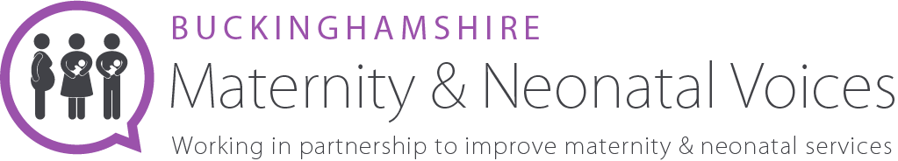

Bucks MNVP Engagement Volunteer
About us
We are an independent team of volunteers and health professionals, working together to review and contribute to the development of maternity services in Buckinghamshire. We welcome all feedback, questions and suggestions.
We are always looking to hear about experiences of maternity care in Buckinghamshire Healthcare Trust. Please look at our website for more information www.bucksmaternityvoices.co.uk

The Role
The Engagement Volunteer will support the existing Chair Team with community engagement throughout Buckinghamshire. Primarily focusing on reaching minority groups, initiating new and developing existing relationships, and finding innovative ways to engage groups which are less heard from. You will be an empathetic, compassionate person. We are looking for someone passionate about helping to shape and improve maternity services within Bucks. Duties may include the below
Feedback
  - Walk the Patch prior to MNVP formal meetings
  - Engage with the LMNS Asset mapping plan to efficiently engage with Bucks based groups
  - Assist in facilitation of community-based feedback sessions
    - Venues to be decided according to need

Networking with other Maternity Forums
  - Actively participate on the MNVP Chairs and Service rep Facebook page
  - Stay up to date with how other MNVPs run - what works well elsewhere

Promotion
  - Be active in promoting the MNVP to the public - possibly writing for local newspapers, magazines, etc.
  - Be active in promoting the MNVP to NHS staff - possibly writing for internal publications, etc.

Our commitment to diversity and inclusion
We believe that our organisation should reflect and represent the full richness of human diversity in terms of background, identity, ability and circumstance. As groups of people currently underrepresented within Bucks MNVP we are particularly keen to receive your application if you are Black, Asian or minority ethnic, LGBTQ+, disabled or under 25.
1.5 Days per month

