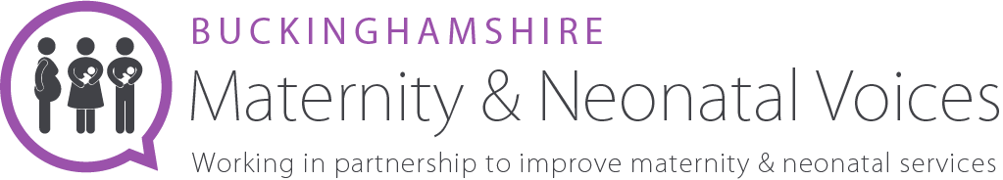

Bucks MNVP Social Media Volunteer
About us
We are an independent team of volunteers and health professionals, working together to review and contribute to the development of maternity services in Buckinghamshire. We welcome all feedback, questions and suggestions.
We are always looking to hear about experiences of maternity care in Buckinghamshire Healthcare Trust. Please look at our website for more information www.bucksmaternityvoices.co.uk

The Role
The Social Media Volunteer will support the existing Chair Team by being responsible for the creation, scheduling and delivery of all social media content across multiple platforms. You will answer private messages by directing people to the correct resource.
Create a social media plan that is in line with Bucks MNVP’s objectives by keeping a regular presence, highlighting public holidays, social calendar events and other key dates and religious celebrations. Content must be sensitively planned out and inclusive. Relevance for families and dads across all minority groups must also be considered.
Main duties
Social media management
  - Be responsible for the day-to-day output and engagement across a range of social media channels including Facebook, Instagram, Twitter and LinkedIn.
  - Develop audience-focused content including copy, graphics or video.
  - Optimise content for each social channel, ensuring high visual and influential impact to ensure best possible engagement.
  - Ensure that tone of voice on our social channels complies with our MNVP values.
  - Be responsive to queries through social media channels in a timely manner and create sensitive, thoughtful and well-thought-out responses to social media messages and comments.
  - Reporting on social media activity, using social insights/analytics and using those to inform activities.

Other duties
  - Attend and contribute to team and MNVP meetings.
  - Stay up to date with how other MNVPs run - what works well elsewhere.
  - Be familiar with and adhere to relevant legislation.

Promotion
  - Be active in promoting the MVP to the public and representing unbiased, culturally aware outward facing personal and social media presence.
  - Be active in encouraging involvement within the MNVP to NHS staff.
Our commitment to diversity and inclusion
We believe that our organisation should reflect and represent the full richness of human diversity in terms of background, identity, ability and circumstance. As groups of people currently underrepresented within Bucks MNVP we are particularly keen to receive your application if you are Black, Asian or minority ethnic, LGBTQ+, disabled or under 25.
1.5 Days per month

