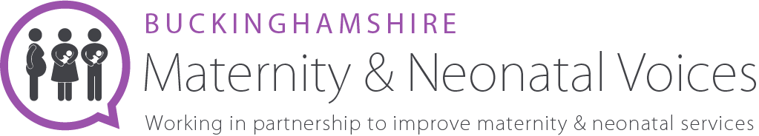

Bucks MNVP Equity & Inclusion Volunteer
About us
We are an independent team of volunteers and health professionals, working together to review and contribute to the development of maternity services in Buckinghamshire. We welcome all feedback, questions and suggestions.
We are always looking to hear about experiences of maternity care in Buckinghamshire Healthcare Trust. Please look at our website for more information www.bucksmaternityvoices.co.uk

The Role
The Inclusion Volunteer will support the existing Chair Team by welcoming all people, regardless of their personal, physical or social characteristics. You’ll aim to promote good practices with different minority groups. You may work with many different community services and groups to engage and support service users and their families that may normally face discrimination or otherwise be apprehensive to share their feedback.
Done brilliantly, inclusion goes beyond the basic legislative requirements. At the MNVP we believe in creating an environment where difference is embraced, and everyone can flourish.
You will support our Chair Team and Engagement Volunteers in their work reaching minority groups to ensure they are culturally sensitive in both action and language. You will be an empathetic, compassionate person. We are looking for someone passionate about helping to shape and improve maternity services within Bucks. Duties may include the below
Feedback
  - Engage and support the Chair Team and Engagement Volunteers by attending feedback sessions, meetings and training sessions.
  - Engage with the LMNS and support with Equity and Inclusion strategies, asset mapping plan to efficiently engage with Bucks based groups.

Networking with other Maternity Forums
  - Actively participate on the MNVP Chairs and Service rep Facebook page
  - Stay up to date with how other MNVPs run - what works well elsewhere.

Promotion
  - Be active in promoting the MVP to the public and representing unbiased, culturally aware outward facing personal and social media presence.
  - Be active in encouraging involvement within the MNVP to NHS staff.
Our commitment to diversity and inclusion
We believe that our organisation should reflect and represent the full richness of human diversity in terms of background, identity, ability and circumstance. As groups of people currently underrepresented within Bucks MNVP we are particularly keen to receive your application if you are Black, Asian or minority ethnic, LGBTQ+, disabled or under 25.
1.5 Days per month

